Christmas Day Menu
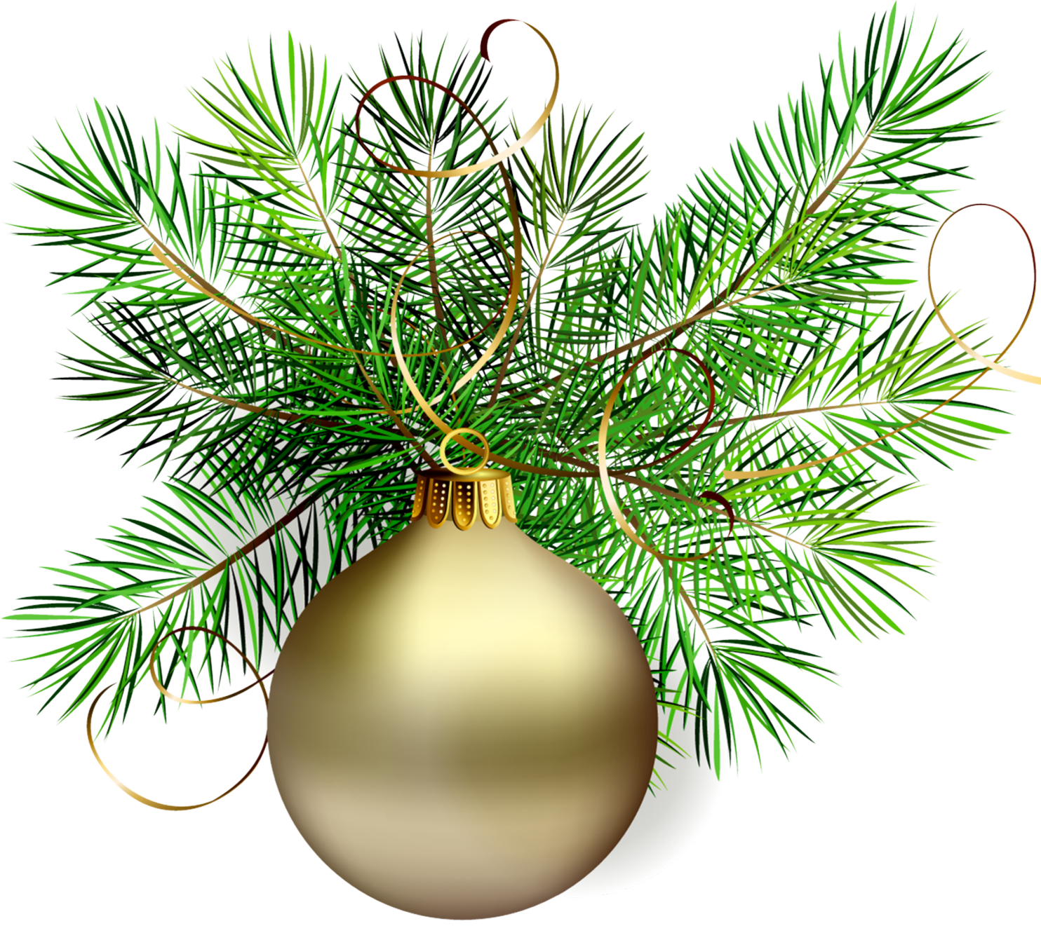
£90 per adult £45 per Child under 13
A welcome drink. Buck Fizz, Prosecco or Fresh orange juice on arrival

Appetisers
Prawn & crayfish cocktail – served with crusty brown bread & butter.
Scallop, black pudding and pea puree- Seared until golden brown, with a pea puree and garnished with crisp bacon lardons.
Duck liver, orange & whiskey pate – served with Melba toast & homemade plum jam.
Baked camembert – served with redcurrant jelly & toasted rosemary focaccia.

Mains
Traditional roast turkey dinner – Christmas dinner accompanied with local vegetables, honey roast parsnips, honey roast carrots, Brussel sprouts, roast potatoes, pigs in blankets, pork stuffing & our popular Foldgate Yorkshire puddings & gravy.
Featherblade beef- served with pomme puree, braised red cabbage, honey roast carrots, minted peas & gravy.
Festive baked salmon – served with garlic roasted new potatoes, honey roast carrots, tender stem of broccoli and dill sauce.
Homemade mushroom, cranberry & chestnut pie – served with pomme puree, honey roast parsnips, honey roast carrots & Brussell sprouts and vegetarian gravy. (V, VEG)

Desserts
Homemade chocolate orange cheesecake – served with cream or ice cream (AGF).
Apple pie (V) – served with cream, ice cream or custard.
Traditional Christmas pudding – served with Brandy sauce, ice cream or custard.
Homemade sherry trifle.
Homemade white chocolate & raspberry brownie – served with cream or ice cream.
Cheese & Biscuits for 2. Supplement of £9.00
To conclude
Coffee or tea
Mince pie
Mint Chocolate
Please talk to one of our team for more information on
Christmas day booking arrangements

